The Adventures of Daniel Boone

Bastion Hunt
5th Grade
Mrs. Victoria Waimon
March 4, 2026

The Adventures of Daniel Boone

Daniel Boone was born on November 2, 1734, in Berks County, Pennsylvania. He grew up in a really big family with eleven children with him being the sixth. At the age of fifteen, he moved from Pennsylvania with his family to Shenandoah Valley in Virginia. After, his family left the Society of Friends, which is better known as a group called the Quakers.
He loved the outdoors and hunting. When he went hunting, he shot a .40 caliber flintlock rifle and wore a coonskin cap. He was best known for hunting and his coonskin cap was a defining piece of his clothing. Although he was best known for wearing the coonskin hat, he preferred wearing a wide-brimmed beaver felt hat to keep the sun out of his eyes.
When Daniel moved, he hunted in Kentucky. When Daniel was 22 when he married Rebecca Bryan. He led the Kentucky Expedition, and he was captured by Indians. His son was killed by Indians. He was also involved with the Battle of Fort Duquesne, led by Edward Braddock. While a part of this war, he met someone named John Findley, who told him about a spot in Kentucky that had a lot of animals to hunt. He hunted deer, buffalo, elk, and a lot of other animals. He made a lot of money from selling the animal skins and meat from his hunting. This got him started as a hunter, and he started to gain popularity.
Daniel Boone's daughter and two other girls were captured by Indians while they were out on a canoe. It was near Boonesborough. Boone took a group of men and chased the Indians in wilderness to get them back. They tracked the Indians for two days and finally caught up with them and rescued all three girls before they could be taken farther. Boone would do anything to protect people he cared about, and he did all of this while having to deal with attacks, sieges, and people trying to take everything he had.
Boone's party moved around a lot. They went from the upper Yadkin Valley, to Tennessee, Virginia, and then to the Cumberland Gap. The war against the Shawnee Indians happened in 1774. He commanded three garrisons during the war against the Indians in 1774, to help protect the settlements. Then his family was captured again by the Indians and taken back toward the Shawnee Indian village. Then they escaped from the Shawnee Indians and had more war with the Indians. They had several town sieges where the Indians surrounded the forts and tried to break through the walls.
One of the most famous things that happened to Daniel Boone in Kentucky was when he went out with thirty men to get salt from a place called Salt Licks. This was about one hundred miles away from a fort they were at Boonesborough. While they were there, they got captured by over one hundred Indians and two French guys. The Indians traded them for money, but they kept Boone. A Shawnee chief named Blackfish made Boone his family instead of killing him.
While Boone was living with the Shawnee he was secretly planning to escape. He found out the Indians were planning an attack on Boonesborough so he snuck away to the fort and told them. When he finally got there, he helped everyone get the fort and when the Indians showed up with five hundred men they had a siege that lasted for days with the Indians trying to dig tunnels, but Boone dug tunnels to stop them and the Indians went home.
Daniel Boone had everything taken. Buffalo Bill claims he did not have one penny left after the ambush and robbery. His wife died on March 18, 1813, at the age of 74 because of a short illness at her daughter's house. Daniel Boone died at the age of 85 years old on September 26, 1820 because of natural causes. Daniel died near Femme Osage Creek in Missouri.
Lessons that can be learned through Daniel Boone's life include courage can still be had through hard times. Daniel Boone shows this because even though he lost his wife, he still kept
moving forward. He still faced troubles with Indians, he got robbed and everything was taken, and he still became one of the most famous frontiersmen and trappers in history.

Illustrations
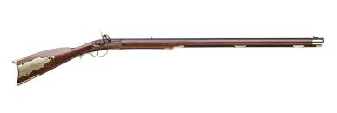  Kentucky Long Rifle .40 caliber flintlock | 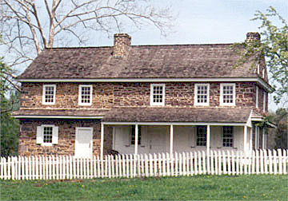  Birthplace of Daniel Boone Berks County, Pennsylvania
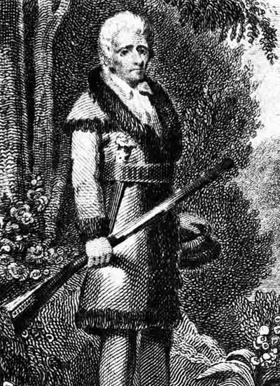  Daniel Boone American frontiersman | 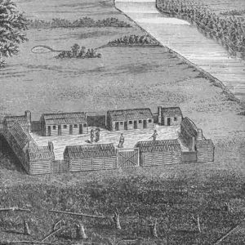  Fort Boonesborough Kentucky, ca. 1778

Bibliography
Cody, William F. “Buffalo Bill's Story of the Wild West and Camp-Fire Chats.” Historical Publishing Company, 1888. River Pines Edition, 2013.
“Daniel Boone.” Encyclopaedia Britannica, Encyclopaedia Britannica, Inc., 8 Jan. 2026, www.britannica.com/biography/Daniel-Boone. Accessed 4 Feb. 2026.
Frick, Lisa. “Daniel Boone.” Historic Missourians, The State Historical Society of Missouri, historicmissourians.shsmo.org/daniel-boone/. Accessed 4 Feb. 2026.

